PRACTICAL-1:- REVISION OF ARRAYS
Problem 1
Aim:- Write a program using C to perform linear search and binary search.
Linear Search
Theory:- We traverse through all the element of the array to find the target element using “for” loop. If the element is found in the array we take the index number and break from the loop or else the loop goes on till the last element of array. At last if element is there “element us found at index” is printed or else “element is not found” is printed.
Code:-
#include<stdio.h>

int main()
{
printf("Linear Search\n");
int n,ele,i,flag=0;
printf("Enter length of array:-");
scanf("%d",&n);
int a[n];
for (i=0;i<n;i++)
{
printf("Enter element:-");
scanf("%d",&a[i]);
}
printf("Enter element to search:-");
scanf("%d",&ele);
for (i=0;i<n;i++)
{
if (ele==a[i])
{
flag=1;
break;
}
}
if (flag==1)
printf("Element found at %d",i+1);
else
printf("Element not found");
return 0;
}
Output:-
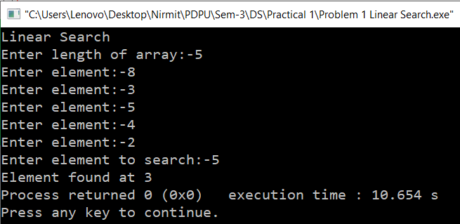
Time Complexity:- O(n) as loop will be iterated through all n elements.
Space Complexity:- O(n) (because array is size of n and ignore input of number n as it has space complexity of O(1))
Binary Search
Theory:- We first check the middle element of array. If the target element is found we break, if it is smaller we check the left half or if it is larger we check the right half. We repeatedly do this until we find the element or the there is no half remaining.
Code:-
#include<stdio.h>
int main()
{
printf("Binary Search\n");
int n,ele,i,flag=0;
printf("Enter length of array:-");
scanf("%d",&n);
int a[n],mid,lb=0,ub=n-1;
for (i=0;i<n;i++)
{
printf("Enter element:-");
scanf("%d",&a[i]);
}
printf("Enter element to search:-");
scanf("%d",&ele);
while (lb<=ub)
{
mid=(lb+ub)/2;
if (a[mid]==ele)
{
flag=1;
break;
}
else if (a[mid]<ele)
lb=mid+1;
else
ub=mid-1;
}
if (flag==1)
printf("Element found at %d",mid+1);
else
printf("Element not found");
return 0;
}
Output:-
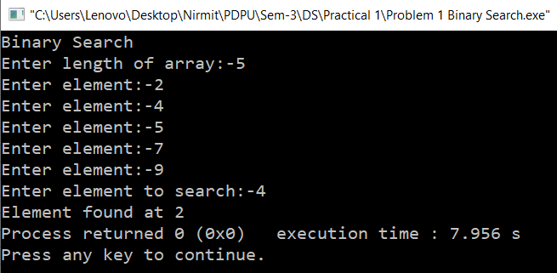
Time Complexity:- O(n)=log2n (approx. = log n [because base doesn’t matter]) ( i=0 then n is the T.C., i=1 then n/2 is the T.C., i=2 then n/4 is the T.C. so when i=n then 1 is the T.C. which will be equal to the pattern formed n/2^i ; then compare (n/2^i) =1 and make i the subject)
Space Complexity:- O(n) (because other 5 constants hold O(1) which can be ignored and mainly array of size n is used)
Program 2
Aim:- Write a program in C to perform bubble sort, insertion sort and selection sort. Take the array size and array elements from user.
Bubble Sort
Theory:- In this we bubble up whatever the largest element is in a particular loop to the last to get the sorted array. We do this by checking adjacent elements. If previous element is bigger it is swapped by the next element or else it is not changed. We do this till the largest element is at the last. We then do it for 2nd largest and so on.
Code:-
#include<stdio.h>
int main()
{
printf("Bubble Sort\n");
int n,i,j,temp,flag=0;
printf("Enter length of array:-");
scanf("%d",&n);
int a[n];
for (i=0;i<n;i++)
{
printf("Enter element:-");
scanf("%d",&a[i]);
}
for (i=1;i<n;i++)
{
for (j=0;j<n-i;j++)
{
printf("g\n");
if (a[j]>a[j+1])
{
flag=1;
temp=a[j];
a[j]=a[j+1];
a[j+1]=temp;
}
}
if (flag==0)
break;
}
printf("Sorted array:- ");
for (i=0;i<n;i++)
printf("%d ",a[i]);
return 0;
}
Output:-
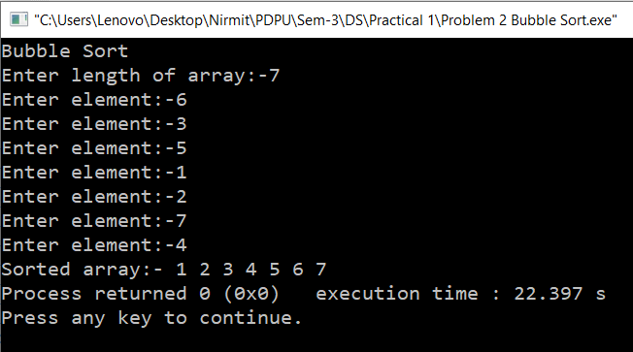
Time Complexity: O(n^2) for worst and average case and O(n) for best case Total iterations: n-1 [best case] and (n(n-1))/2 [worst case]
Space Complexity:- O(1)
Insertion Sort
Theory:- In this we take a sorted side and an unsorted side. We take one by one every element as key of the unsorted side. If the key is smaller than any of the element we shift the element to +1. We do this till key is larger or the index has run out of range (which means there is no more element to check). We do this for till the array is sorted.
Code:-
#include<stdio.h>
int main()
{
printf("Insertion Sort\n");
int n,key,i,j,k,temp;
printf("Enter length of array:-");
scanf("%d",&n);
int a[n];
for (i=0;i<n;i++)
{
printf("Enter element:-");
scanf("%d",&a[i]);
}
for (i=1;i<n;i++)
{
key=a[i];
j=i-1;
while (j>=0 && a[j]>key)
{
a[j+1]=a[j];
j-=1;
}
a[j+1]=key;
}
printf("Sorted array:- ");
for (i=0;i<n;i++)
printf("%d ",a[i]);
return 0;
}
Output:-
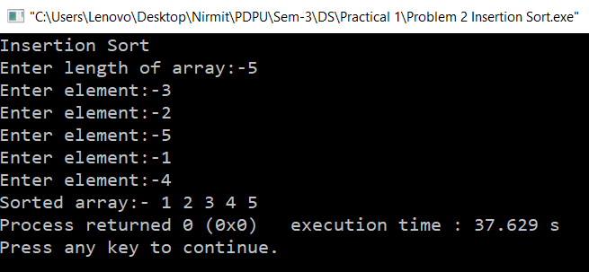
Time Complexity:- O(n^2) [worst case] and 0(n) [best case ]
Space Complexity:- O(1)
Selection Sort
Theory:- In this we swap the position of the minimum value of the array to first, then we start the array from 2nd number and do the same thing. To do so in 1st loop we first take minimum element as the 1st no. only and check whatever the minimum no. is in the array till the last no. and swap it with the 1st no. After that in 2nd loop we take 2nd as minimum and repeat the process. We do this till array is sorted.
Code:-
#include<stdio.h>
int main()
{
printf("Selection Sort\n");
int n,i,j,min,temp;
printf("Enter length of array:-");
scanf("%d",&n);
int a[n];
for (i=0;i<n;i++)
{
printf("Enter element:-");
scanf("%d",&a[i]);
}
for (i=0;i<n-1;i++)
{
min=i;
for (j=i+1;j<n;j++)
{
if (a[j]<a[min])
min=j;
}
temp=a[i];
a[i]=a[min];
a[min]=temp;
}
printf("Sorted Array:- ");
for (i=0;i<n;i++)
printf("%d ",a[i]);
return 0;
}
Output:-
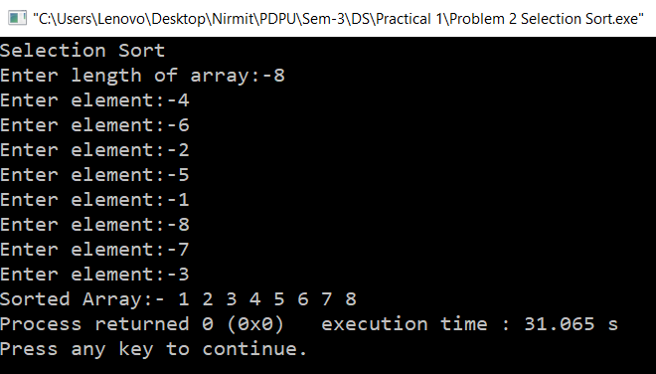
Time Complexity:- O(n^2) for worst, average and best case
Space Complexity:- O(1)
Program 3
Aim:- Write a program in C that obtains the minimum and maximum element from the array. Modify this program to give the second largest and second smallest element of the array.
Theory:- In this we check the first two numbers. The one largest will become the maximum and 2nd minimum number and the smallest becomes the minimum and 2nd maximum number. We then the run the loop till last element in the array. In it if an element is greater than the 2nd max no. the element becomes the 2nd max no. Then if this no. is greater than the max no. then we swap the values. In minimum we check if that element is smaller than 2nd min no. if it is the element becomes the 2nd min no. Then we check this with min no. it is then we swap the values.
Code:-
#include<stdio.h>
int main()
{
printf("Maximum,Minimum and 2nd Max & Min\n");
int n,i,max,min,max2,min2,temp;
printf("Enter length of array:-");
scanf("%d",&n);
int a[n];
for (i=0;i<n;i++)
{
printf("Enter element:-");
scanf("%d",&a[i]);
}
if (a[0]>a[1])
{
max=a[0];
max2=a[1];
min=a[1];
min2=a[0];
}
else
{
max=a[1];
max2=a[0];
min=a[0];
min2=a[1];
}
for (i=2;i<n;i++)
{
if (a[i]>max2)
{
max2=a[i];
if (max2>max)
{
temp=max;
max=max2;
max2=temp;
}
}
if (a[i]<min2)
{
min2=a[i];
if (min2<min)
{
temp=min;
min=min2;
min2=temp;
}
}
}
printf("Maximum:-%d\n2nd Maximum:-%d\n2nd Minimum:-%d\nMinimum:-%d",max,max2,min2,min);
return 0;
}
Output:-
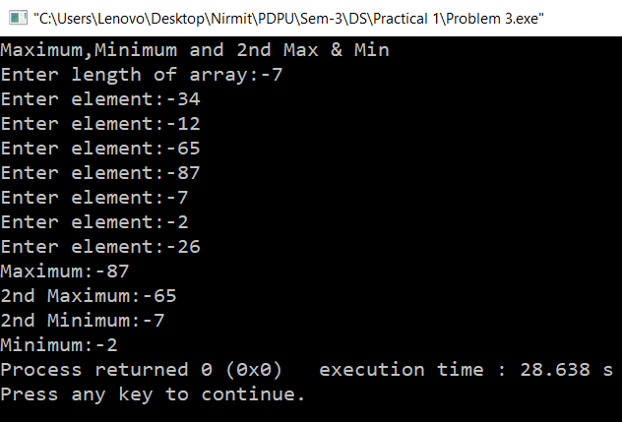
Time Complexity:- O(n)
Space Complexity:- O(1)

